Meeting with Hardware Design Team - 2/6

**Objectives:**

**Accomplishments**

**Notes**

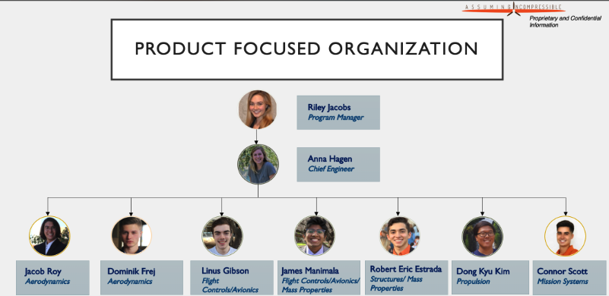

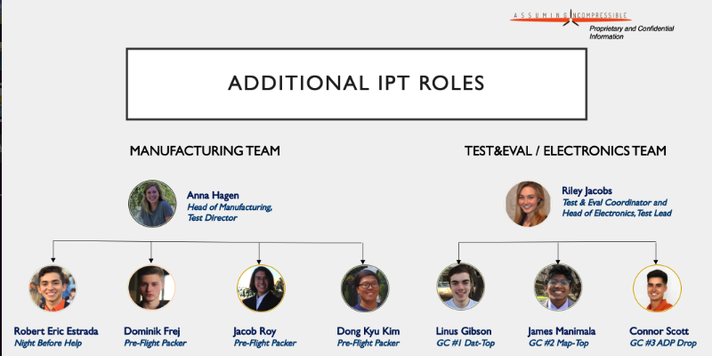

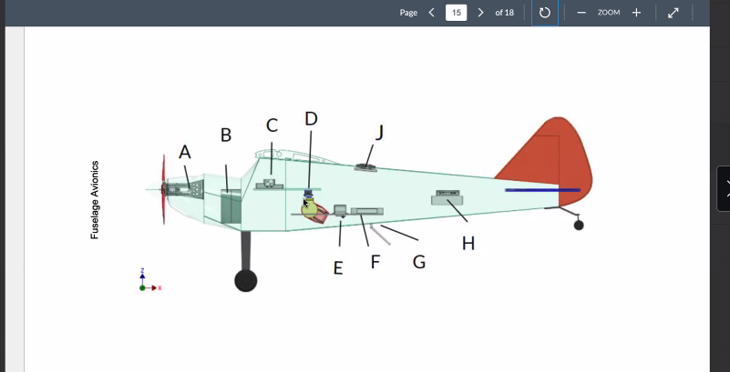

* Right now, the hardware team is planning on using Arduino as a co-processor
* Ideally, the hardware team has a perception of the flight plan that includes making an initial passover (sweep pattern) to cover a defined area of interest to determine the GPS coordinates of the targets.
* Mission planner is sending information to the Pixhawk Autopilot and the Pixhawk is sending

**Hardware Team Structural Properties**

* The hardware team has a constraint on volume of the fuselage
* There are certain things we must have in certain areas. The Pixhawk Autopilot gives us kinematics readings which must be close to the center of gravity of the UAS and the pitot tube measures flow velocity and must be located on the wings
* The autopilot can be pushed back to as far as element D on the diagram
* The UAS switches from manual to autonomous flight mode mechanically through the flip of a switch with communicating with Mark

1. **Objectives**

- Study the Autopilot and ADP (Airdrop Payload Mechanism) subsystem components in the aircraft to understand how satellite imagery is generated, stored, and transmitted. The GPS location runs through the autopilot. Studying these subsystems will be useful for understanding how the map generation from satellite imagery can be integrated with payload release mechanism, and ultimately, how it can all be automated

- Goal is also integrate zoom view camera with capability of narrowing field of vision with automatic target recognition algorithm. Perhaps, the algorithm can be designed under altitude conditions of the aircraft (ideally 200-250 ft) that are needed for minimum resolution to distinguish between frowny and smiley faces where all information on TOI can be captured in a single pass, or as few passes as possible

- Look into co-processors that are industry/commercially available that plug directly into the Pixhawk mechanism, otherwise there are manually technologies like Raspberry Pi that take a longer period of time to integrate with the software

**In Progress**

**Next Steps**

1. Communicate with Riley on Monday to determine the data format of mission planner, atmospheric, and kinematics, readings

**Questions/Concerns**

1. What are the differences between the Arduino and co-raspberry co-processors; the advantages to both? Look into using Arduino and integrating with the Pixhawk
2. How will the data collected by mission planner and atmospheric software differ?
3. At a high-level, how does information flow from